TASK 9:

* Learn about Virtual Private Network (VPNs) and their types.
* Create a Point-to-Site(P2S) VPN gateway from your Virtual network to your individual

computer.

* Test the connection while pinging.

**Learning:**

A Point-to-Site (P2S) VPN gateway connection lets you create a secure connection to your virtual network from an individual client computer. A P2S connection is established by starting it from the client computer.

**Virtual Network Gateway** sends encrypted traffic between azure Vnet and

on premise location over the public internet.

Steps to perform point-to-site peering:

Step 1: Create a Virtual Network with subnet ‘subent1’ and add gateway subnet in it with name ‘GatewaySubet’.

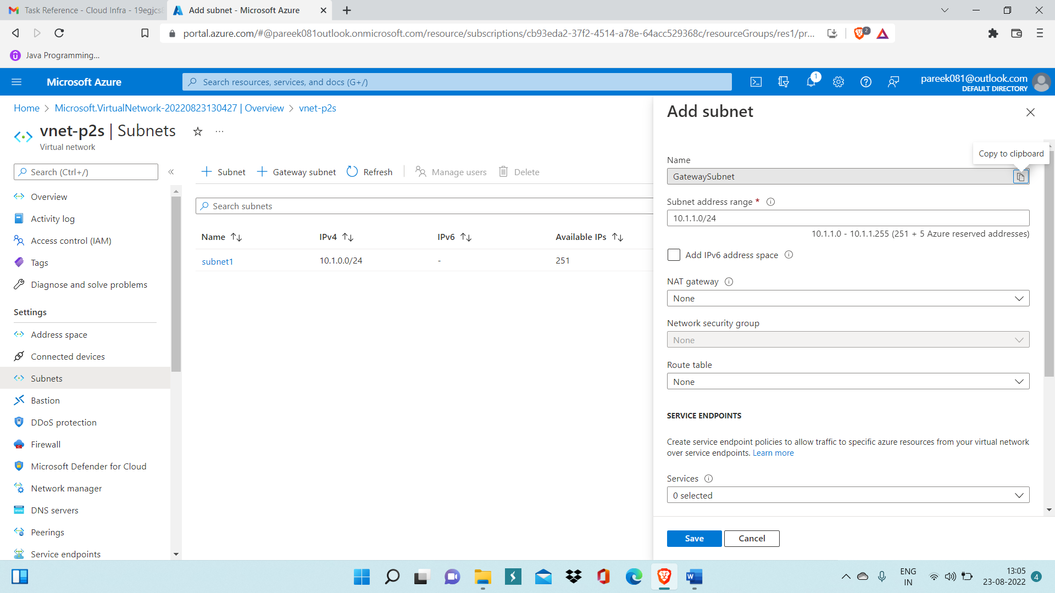

Step 2: Create Virtual Network Gateway using virtual network ‘vnet-p2s’ and deploy it.

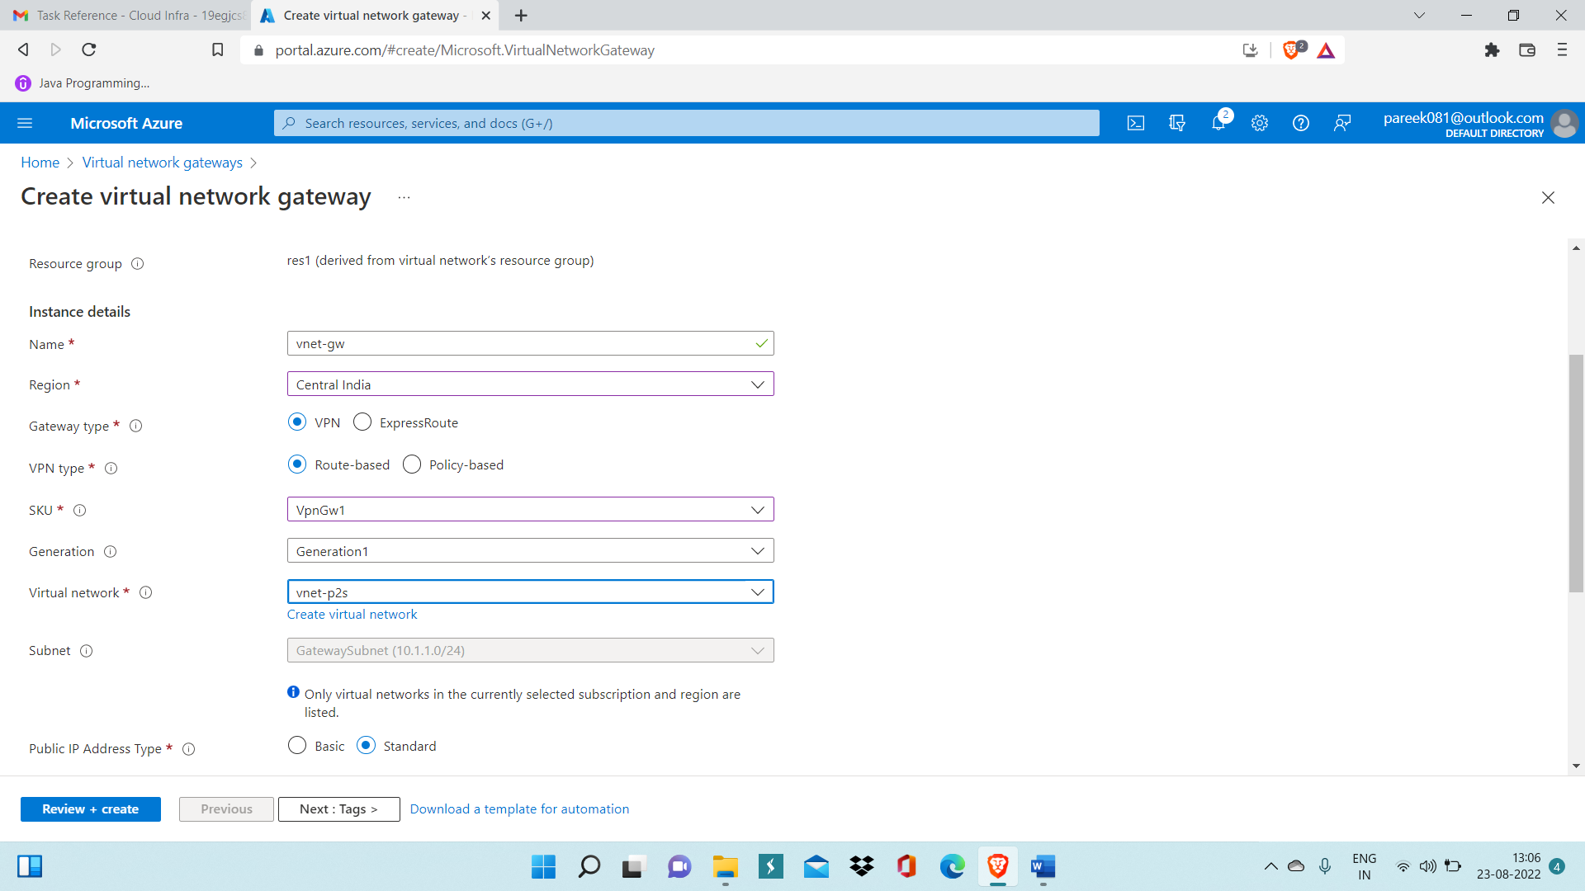

Step 3: Create virtual machine ‘vm-p2s’ inside virtual network ‘vnet-p2s’

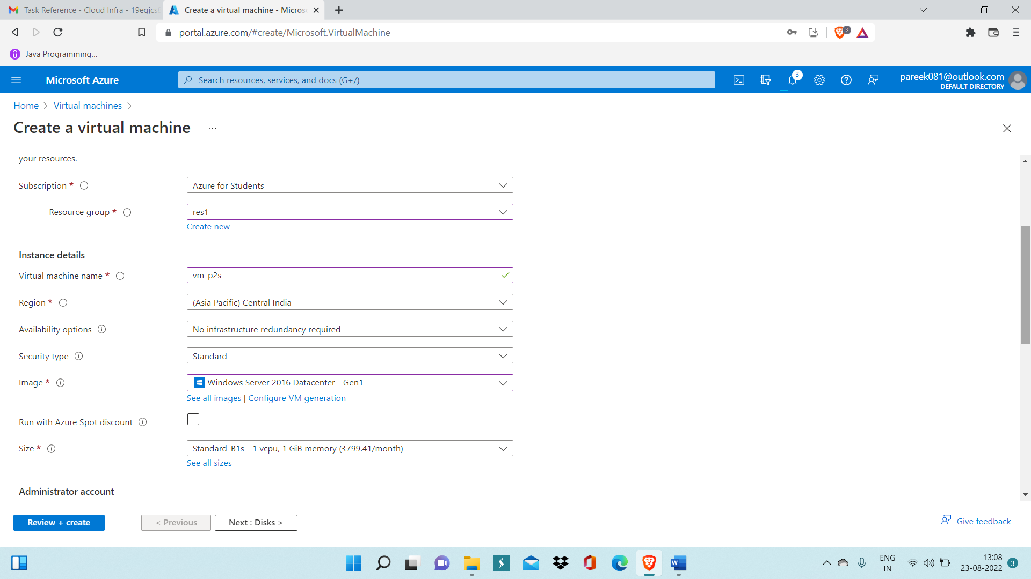

Step 4: Until Virtual Network Gateway gets deployed, create root and client certificate on your local computer using Windows Powershell.

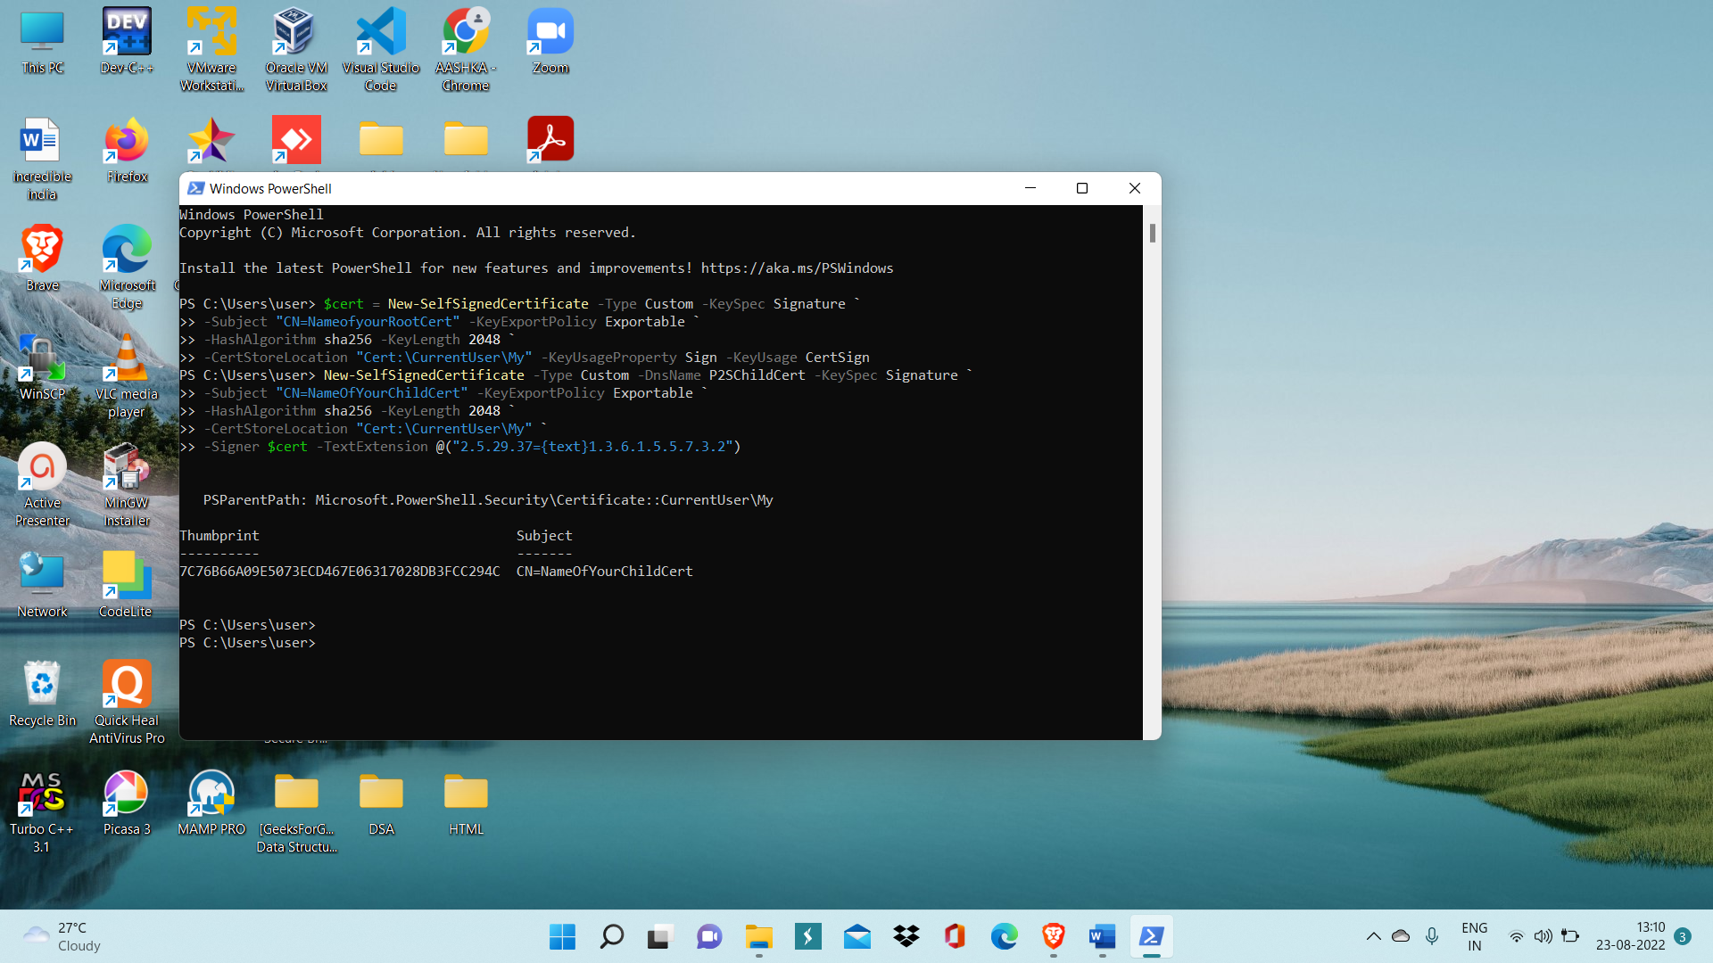

Step 5: Run command ‘certmgr’ and certmgr dialog box will get opened.

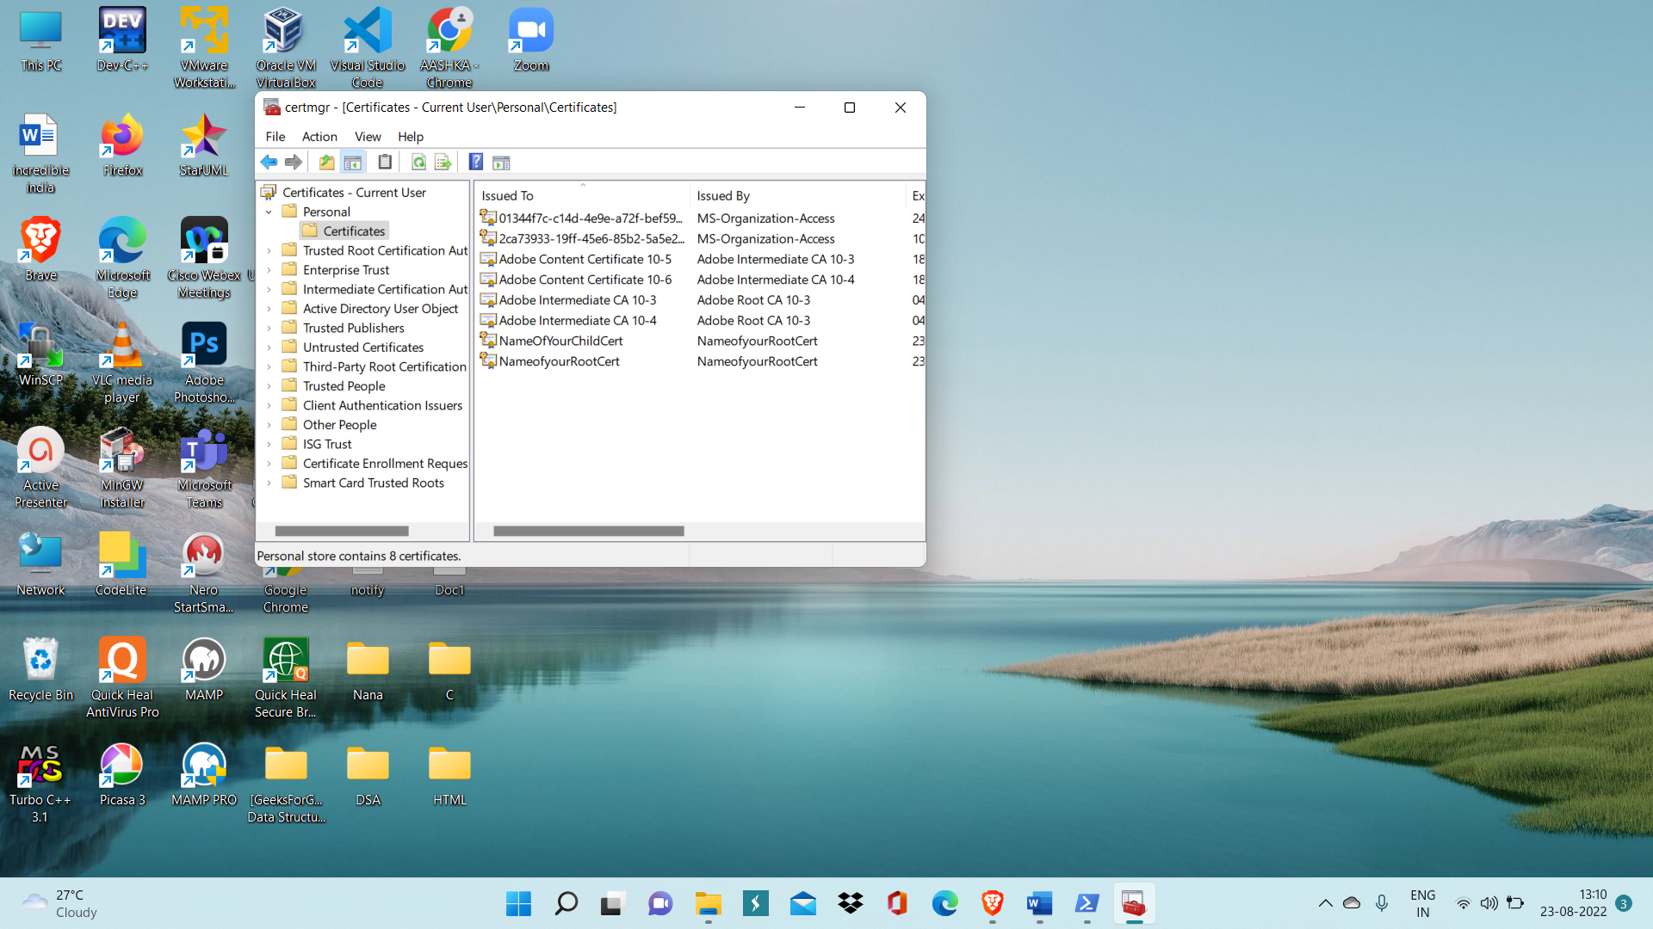

Step 6: Export root certificate.



Step 7: GO inside Point-to-site configuration of Virtual Network ‘vnet-p2s’ after it is deployed and Click on Configure now.

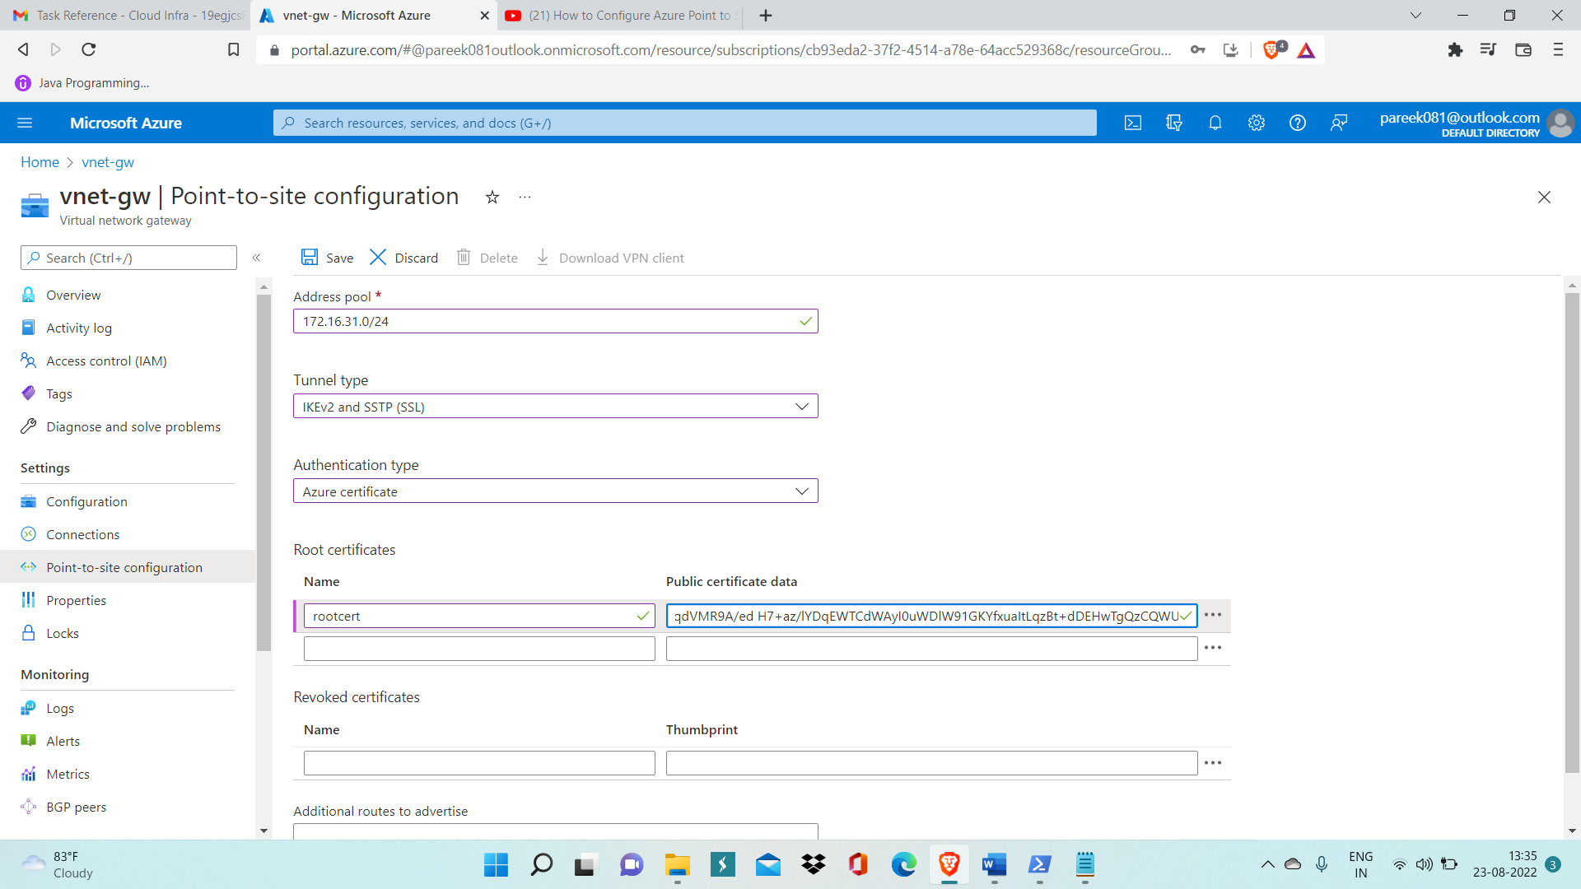

Step 8: Inside Public certificate data copy key of rootcert which oyu hace opened in notepad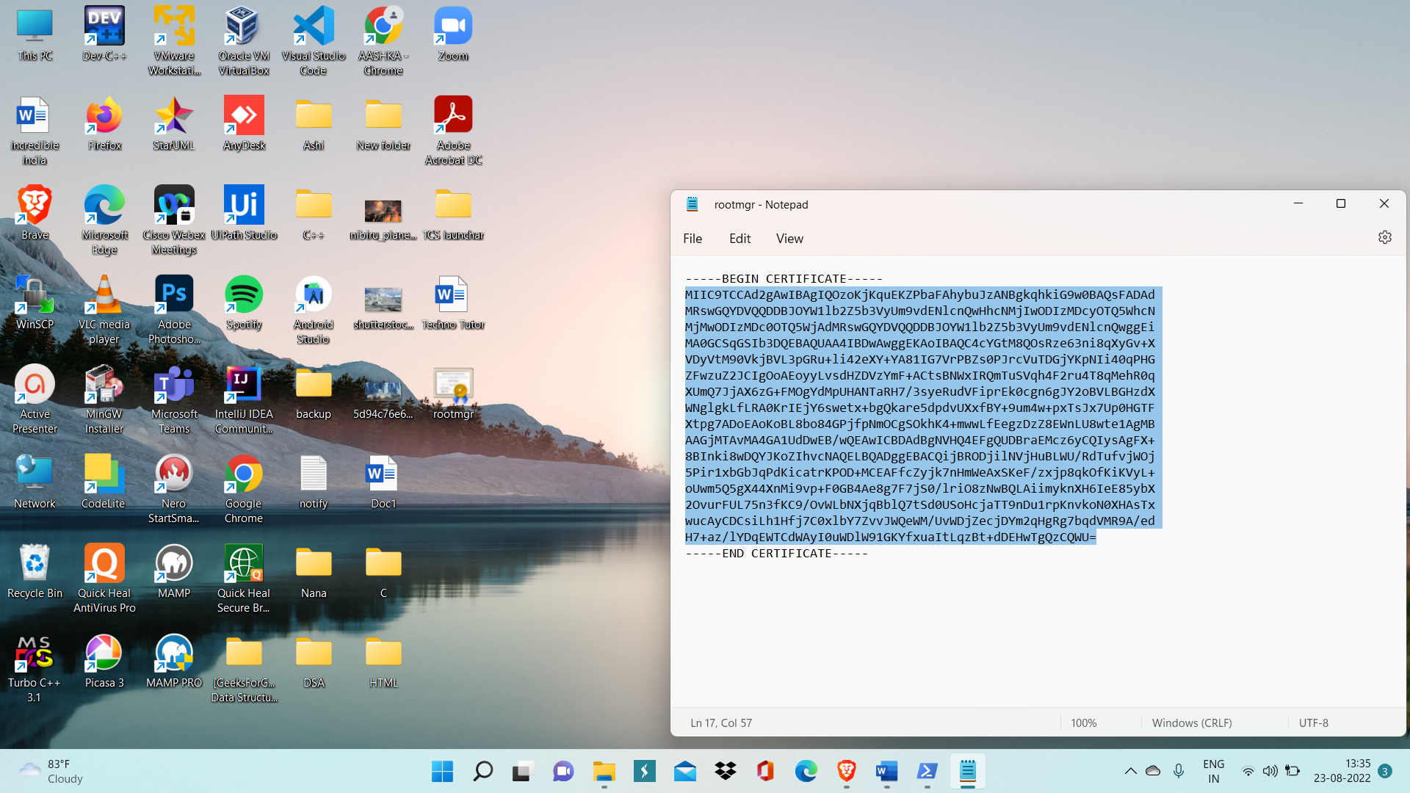

Step 9: Then Download VPN Client.



Step 10: Now install VPN client inside local computer and connect vnet-p2s.

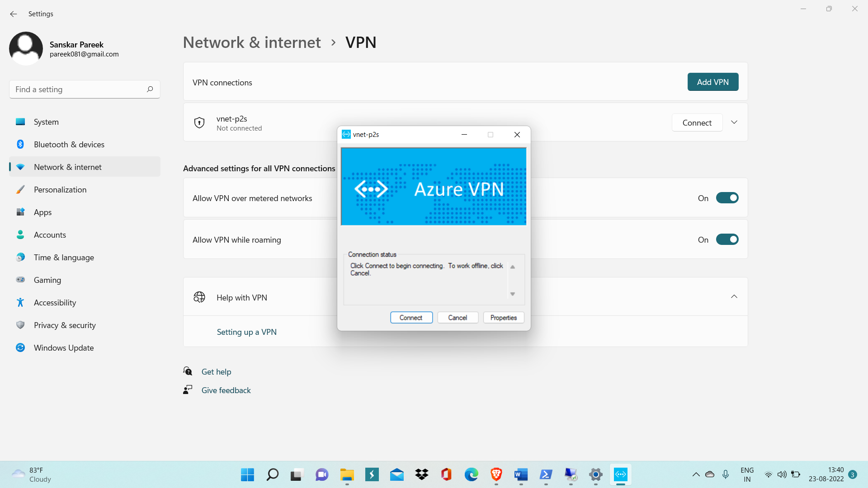

Step 11: Go inside VM and inside Advanced Firewall Settings you need to enable two inbound port rules i.e. File and Printer Sharing for ICMPv4 and ICMPv6



Step 12: Now copy private of your VM which is written inside overview page of vm-p2s

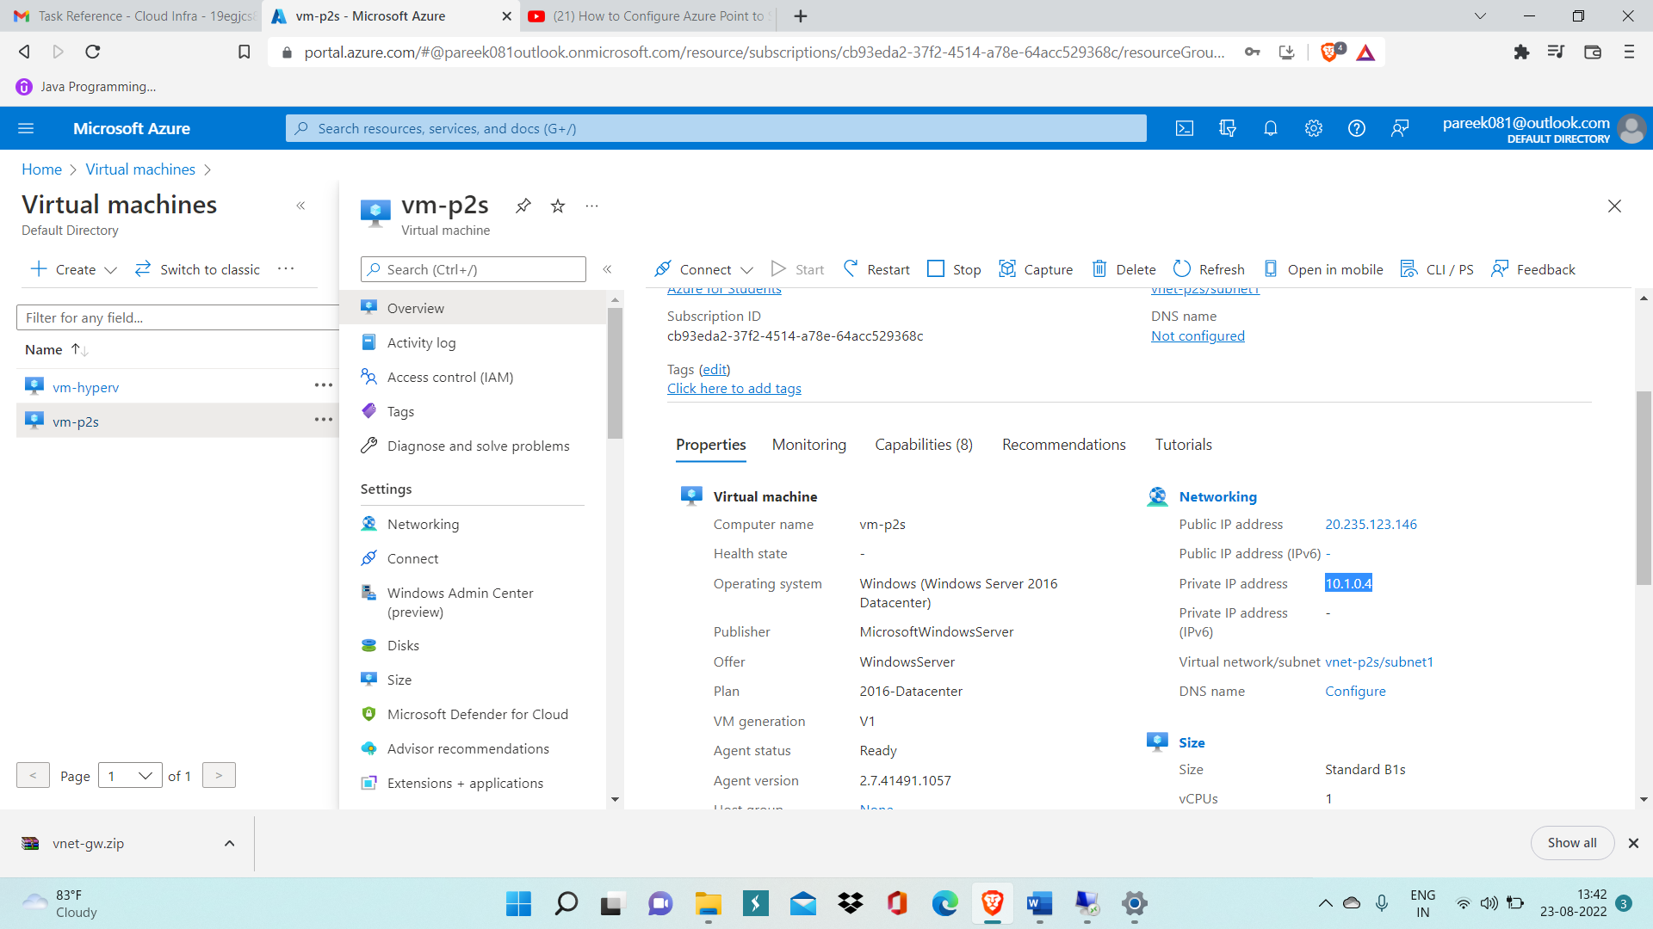

Step 13: Now Open Windows Powershell on your local computer and write command ‘ping 10.1.0.4’ to check p2s connection is properly established or not.

Here 10.1.0.4 is the private IP of vm-p2s.

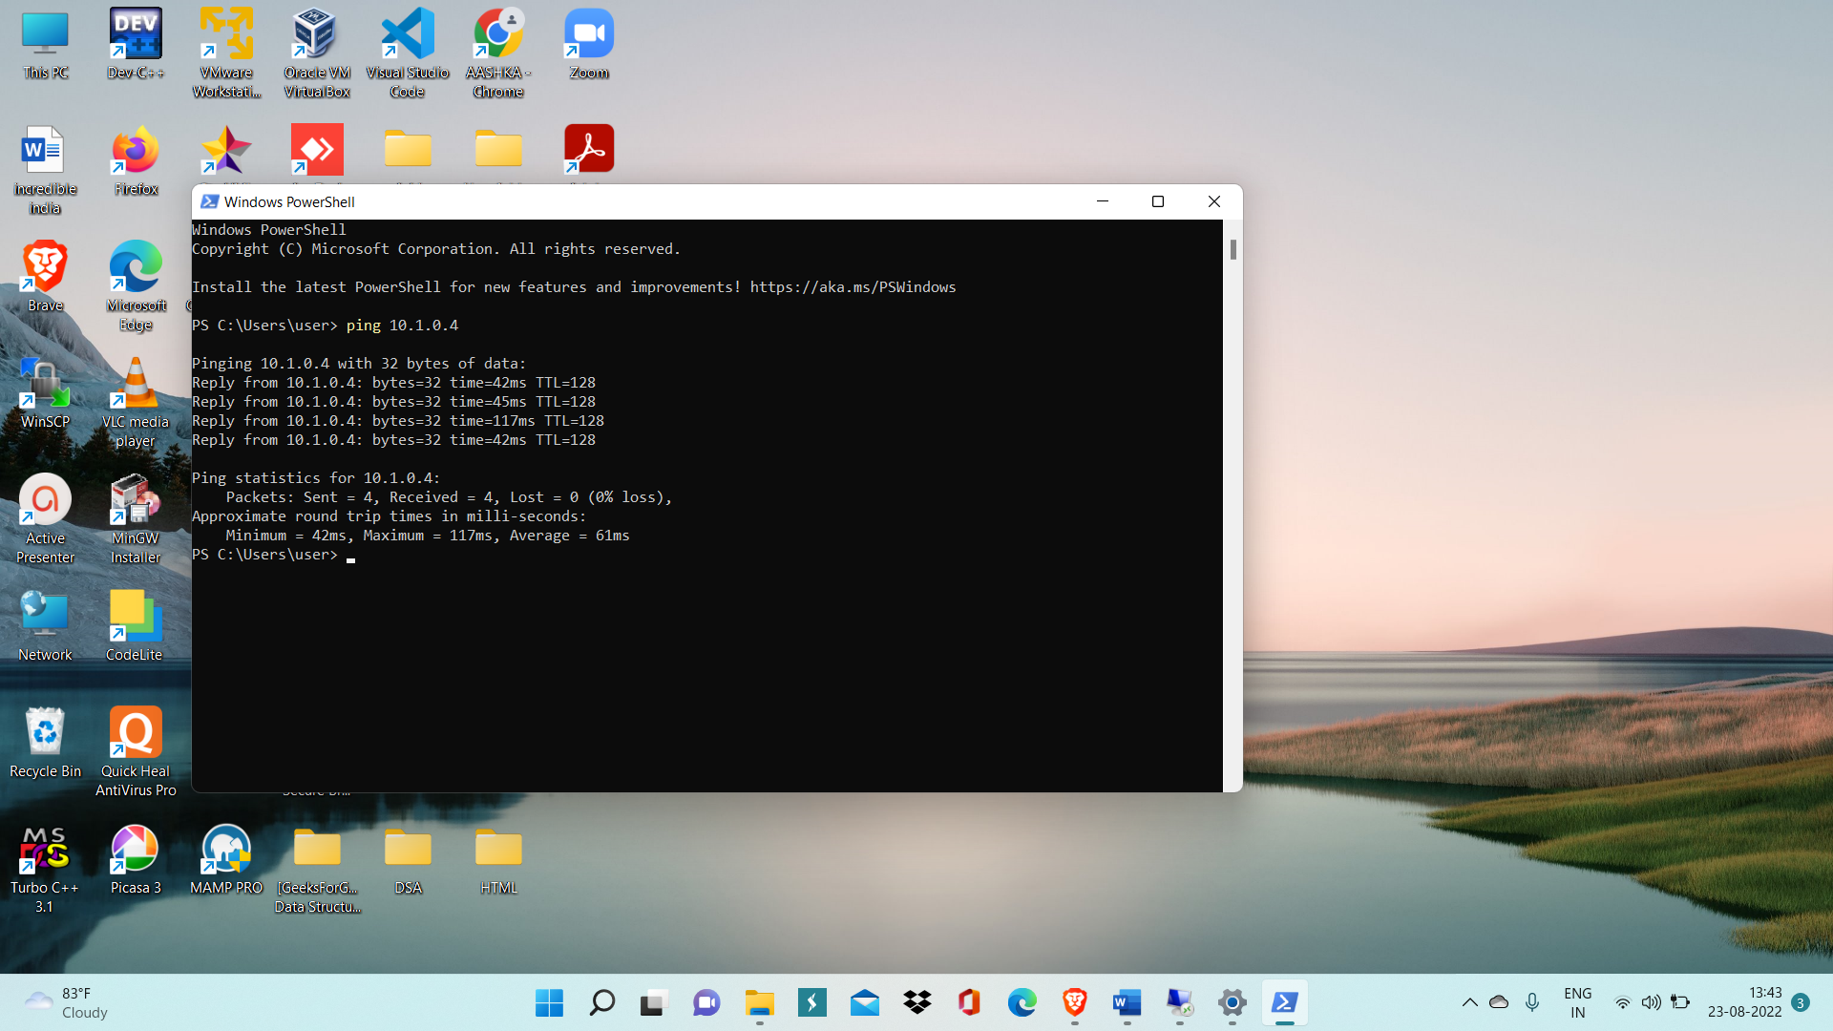

So, p2s connection is properly established.